7.27: a) The displacement is in the y-direction, and since 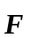 has no y-component, the work is zero.
b)
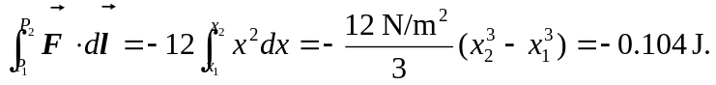
c) The negative of the answer to part (b), 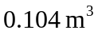 d) The work is independent of path, and the force is conservative. The corresponding potential energy is 